1 NMAP Scan
So, we first use a tool called NMap to scan the IP address to know which services are running and what vulnerabilities it might hold.
Nmap -sV -Pn -p- wgel.thm -o nmap_result_wgel.txt

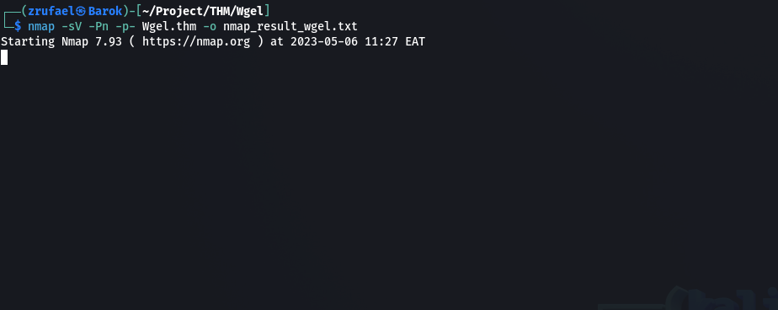

|_http-title: Apache2 Ubuntu Default Page: It works

2. I checked port 80
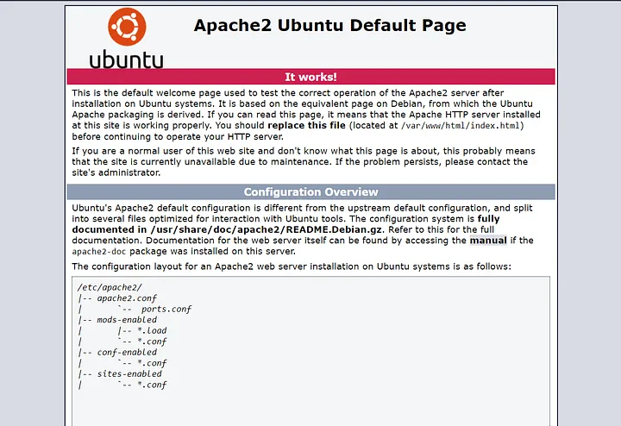

then I checked the sources then I get

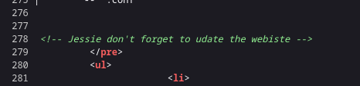

“ Jessie “ it me be Username

3. I used dirb to find directorys on the web

dirb http:// wgel.thm

a get ssh key
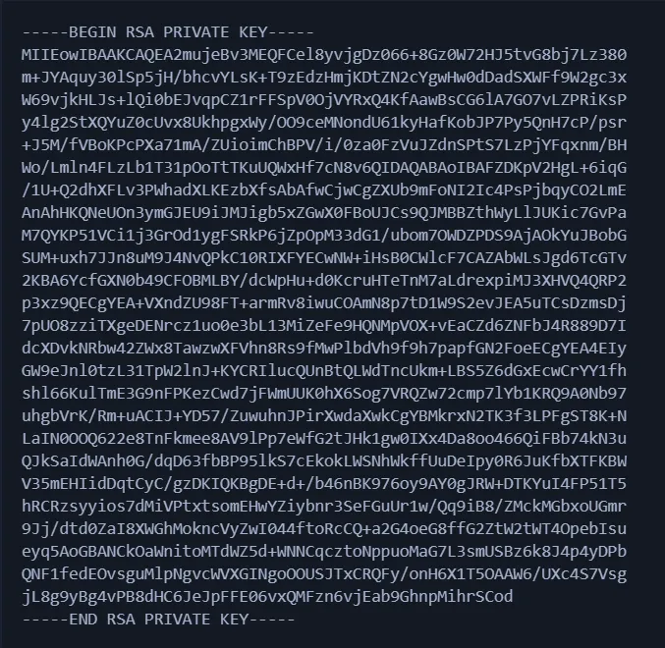

on http://wgel.thm/sitemap/.ssh

4. I saved “ssh key”
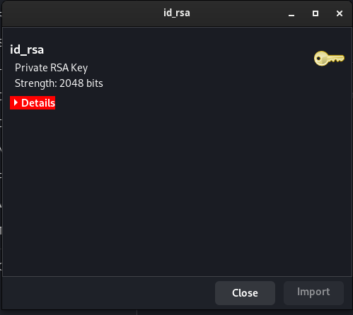

5. connecting to the user by using SSH KEY and USERNAME

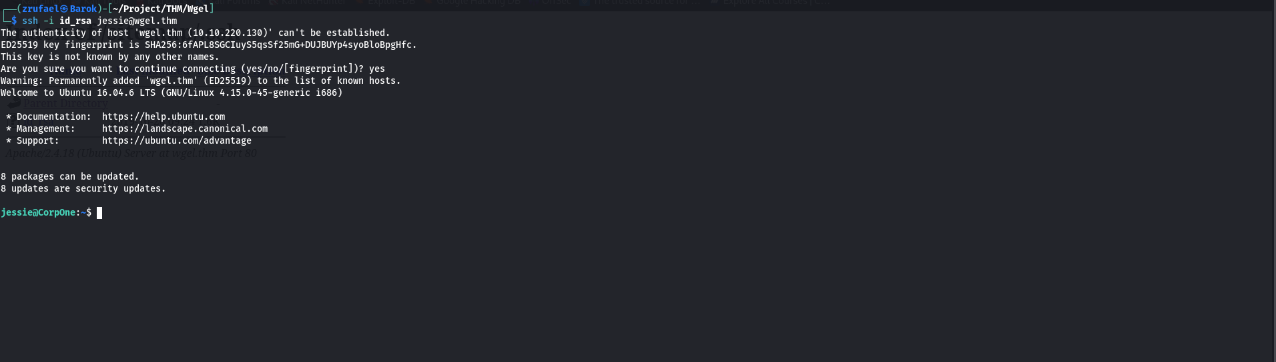
BOOM!!

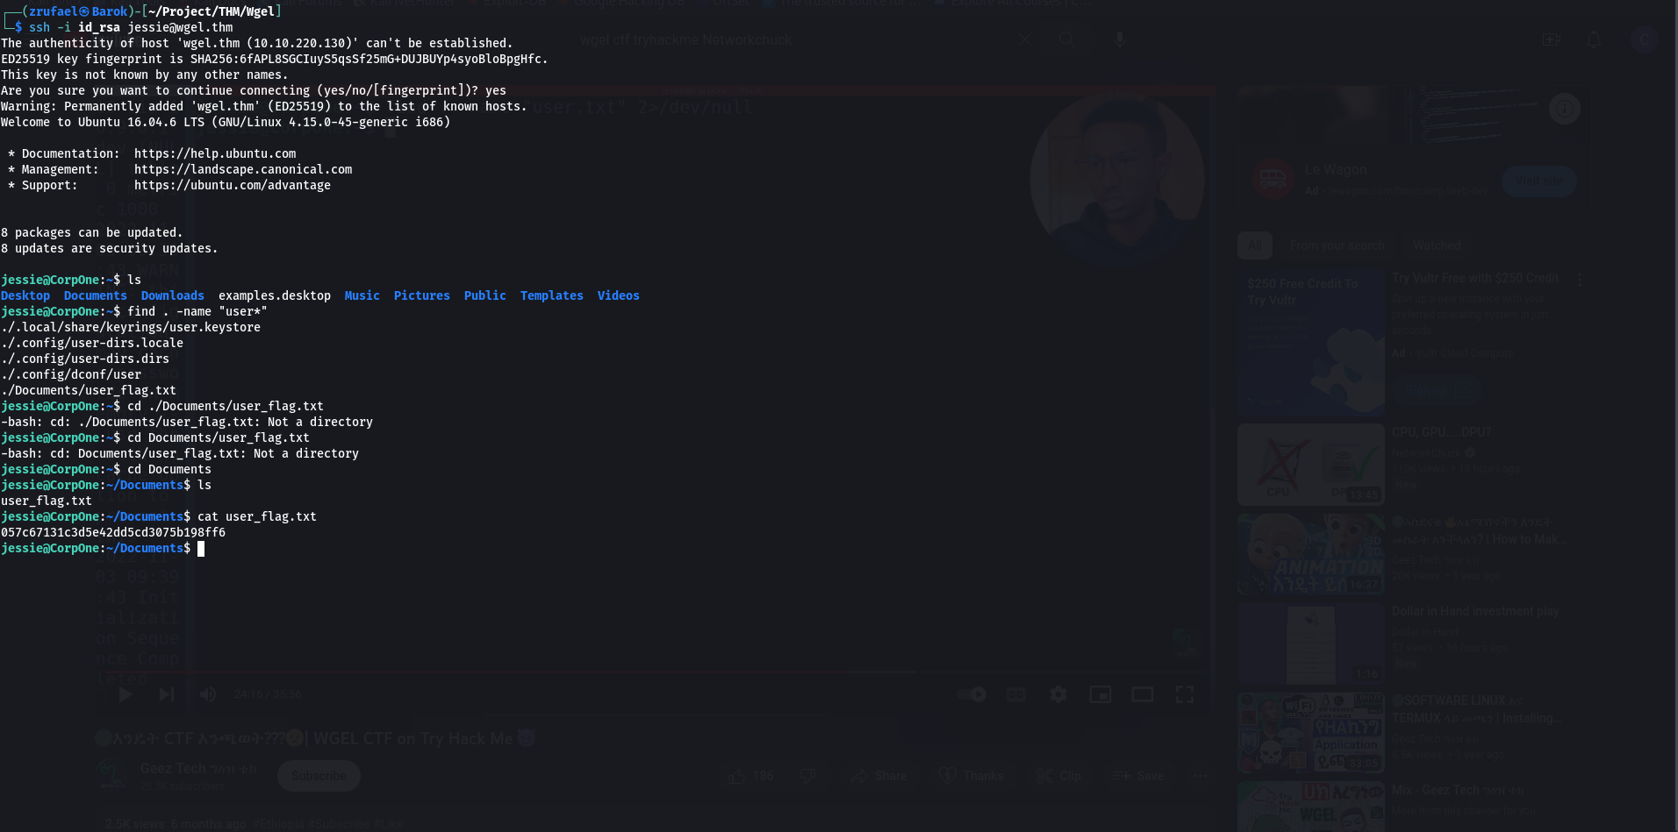
6. USER flag

To get simply I used

‘ find -name “user*” ‘
then I get this

“057c67131c3d5e42dd5cd3075b198ff6”

7. ROOT Flag
Privilege Escalation
sudo -l
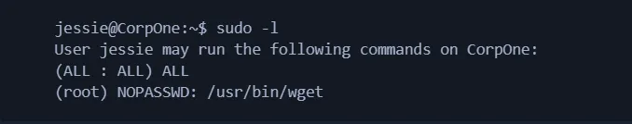
finally I get

“b1b968b37519ad1daa6408188649263d”
Then

8 BOOM!!!

